(Please leave the first two lines brank.)

Title Comparative analyses of ……….
…………………………… （Times New Roman 10.5 points）

Names of Authors Taro SEKAI¹⁾, Hanako ISAN¹⁾, XXX XXXX²⁾（Times New Roman 10.5 points.）

Affiliations 1) World Heritage Studies & World Cultural Heritage Studies, Graduate School of Comprehensive Human Sciences, University of Tsukuba
2) Department of XXXX, XXXX National Museum（Times New Roman 9 points.）

Abstract: ………………………….………………………….………………………………. ……………………………….……………………………….………………………………. ……………………………….……………………………….………………………………. ……………………………….……………………………….……………………………….
(Abstract in English. Within 300 words. Times New Roman 9 points.)

Keywords: XXXX, XXXX, XX, XXX, XXX, XXX. (4 –6 words.)

1. Introduction （Times New Roman 9 points.）
Today there are ……..

2. Materials and Methods (or Methods)
(1) Study Sites

(2) Methods
1) Interview to Local People

2) Literature Research

3. Results

4. Discussion

5. Conclusions

6. Acknowledgements

7. Literature Cited
※Examples

＜Journal Paper＞
Smith, W. L. and Anderson, A. A. 2000.Trends of world heritage. Journal of Natural Sciences 34: pp. 500–512

＜Book＞
Smith, W. L. 1999. The Discovery of New Plants in XX Islands. 2nd edition. Science Inc., London

Smith, W. L., Anderson, A. A., and Takahashi, K. 1984. Conservation of world heritage in Japan. In Sasaki, D. and Hiraoka, S. (eds.): Introduction of World Heritage Studies, pp. 30–60. Tsukuba Press, Ibaraki, Japan

＜Website＞
MINISTRY OF XXXX, USA. 2012. List of XXXX in the United States of America. http://www.XXX.XX.XX/XXXX/XXXXX.html [accessed 26 March 20XX]

<Citations in Text>
Smith and Anderson (2000)
Yamada et al. (2006)
(Takahashi 1998, 1999)
(Saito 1998; Wada et al. 2000)

※Please do not use footnotes for citing references.

Examples of Table

Table 1．Results of interviews to volunteers engaged in voluntary work for conservation of XX
 | A city |  |  | B city
 | Students | Non-students |  | Students | Non-students
Satisfied | 15 | 20 |  | 10 | 5
Ordinary | 3 | 2 |  | 1 | 3
Unsatisfied | 1 | 1 |  | 2 | 3
Other | 0 | 1 |  | 0 | 0
計 | 19 | 24 |  | 13 | 11

Examples of Figure (Photograph)
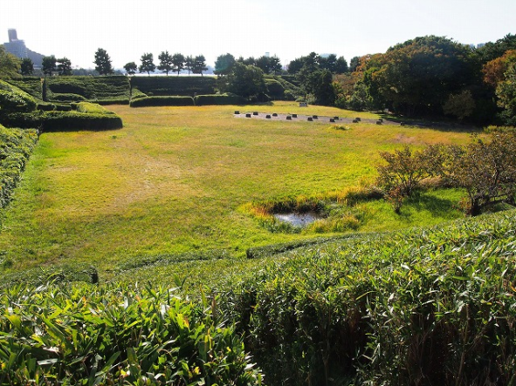
Figure 2. Research site (photograph was taken by Taro SEKAI)

※Photographic figures should be embedded with a high resolution (approximately 1-2 M/photo or 150-300 dpi), but please do not exceed 20M for an entire paper.

※Please include a name of photographer in figure captions. We do not allow authors to include photographs of artificial works (e.g., paintings) whose copyrights could be violated by online publications.

Example of Figure (graph)

Figure 3. Changes of budgets for conservation of heritages in XX city

※The word 'Figure' should be abbreviated in the text, e.g. Fig. 1, Figs 2 & 3.

Address of Corresponding Author (Please describe following a format below)

(Corresponding Author)
Name: Taro SEKAI (Times New Roman 9 points)
Address: XX street, XX city, XX, US. (Times New Roman 9 points)
Email：XXXX@XXXX.XXX.XX（Times New Roman 9 points.）

※ Please set the number of lines “50” in your word-processing software.
※ Please use this template for preparing Research Note also.
※ Please limit the length of a paper within 20 pages. If author(s) need more pages than 20, please consult the editorial office.

（2015. XX. XX.）

